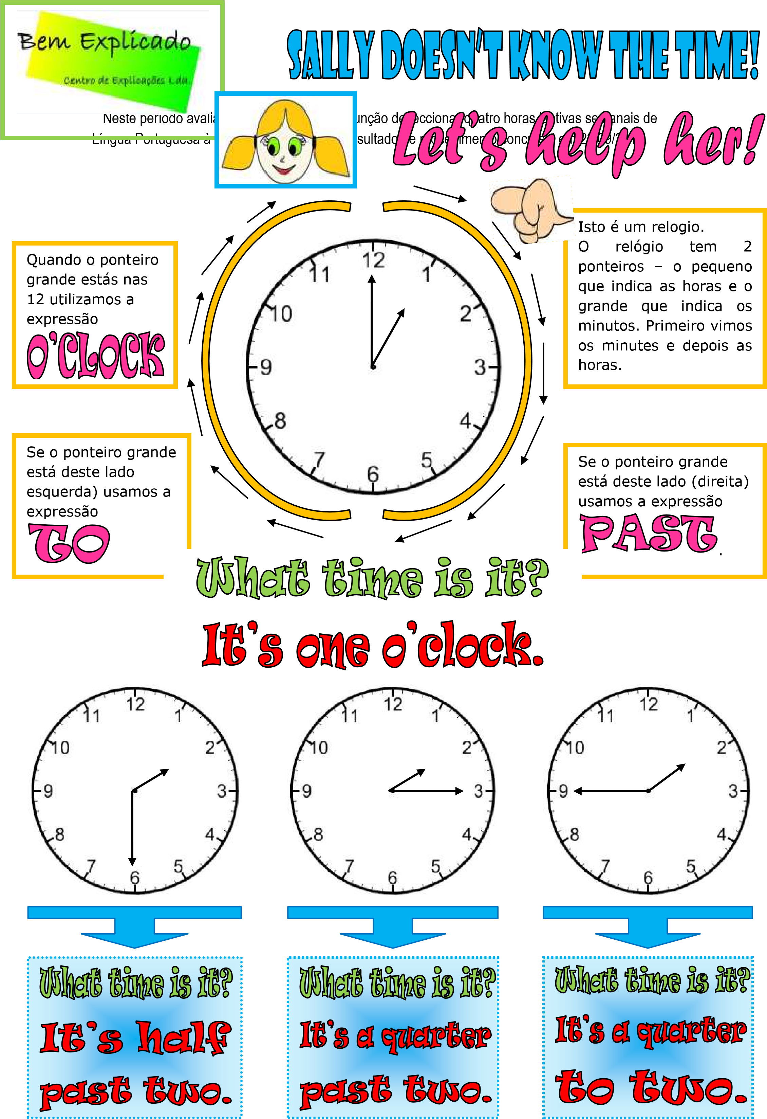

it's nine and eleven

it's nine and twenty-five

it's four and forty-one

it's eleven and forty-five

it's a quarter past six

It’s five on clock

it's 9 and 10

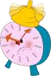

**What time is it? Write complete sentences next to each clock.**

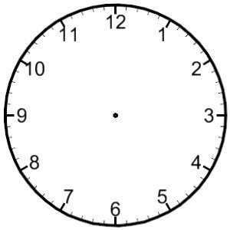

**____________________________________________**

**_________________________**



**_____________________________________________________________________**



**_____________________________________________________________________**

**_____________________________________________________________________**

**_____________________________________________________________________**

**_______________________**

**______________________________________________**



**_____________________________________________________________________**



**Now do the opposite**

**–**

**draw the clock ha**

**nds.**



It’s four o’clock.

It’s five past eight.

It’s two to two.

It’s half past six.

It’s twenty to three.

It’s a quarter to nine.

It’s twelve o’clock.